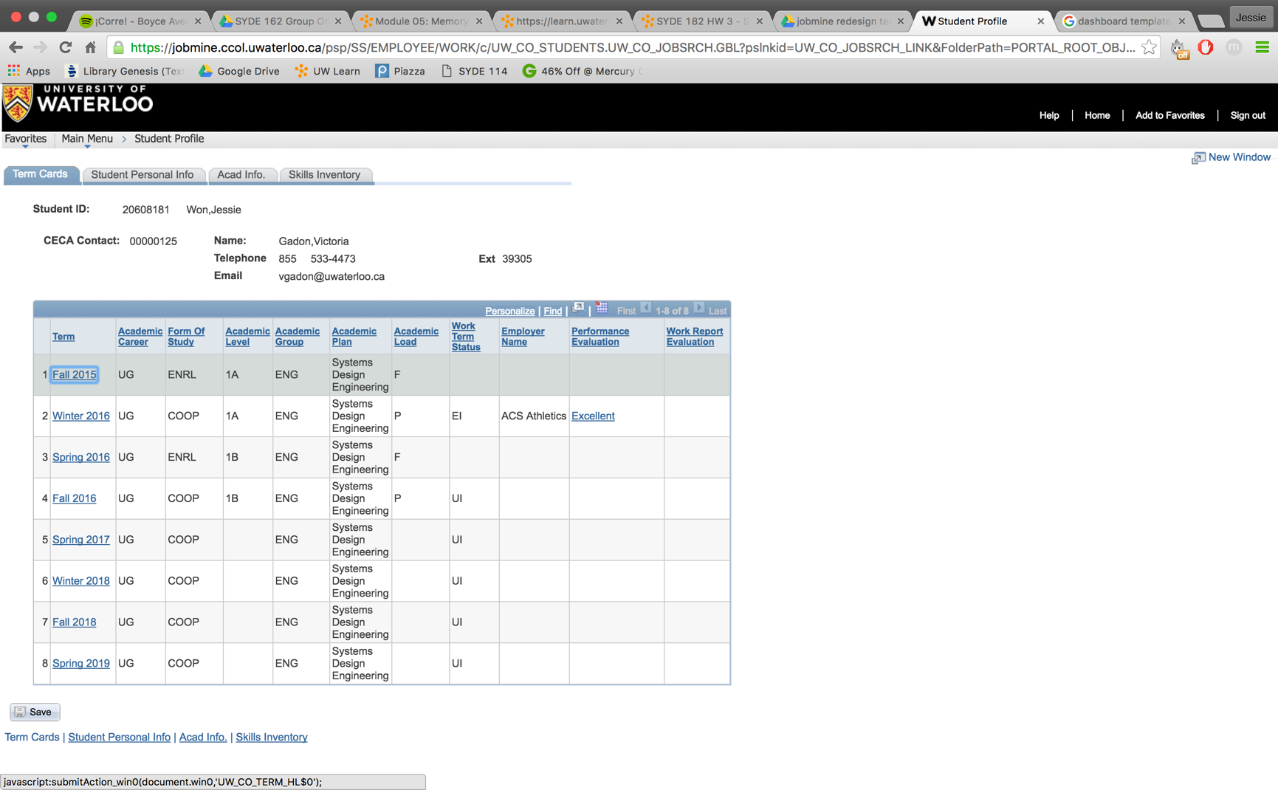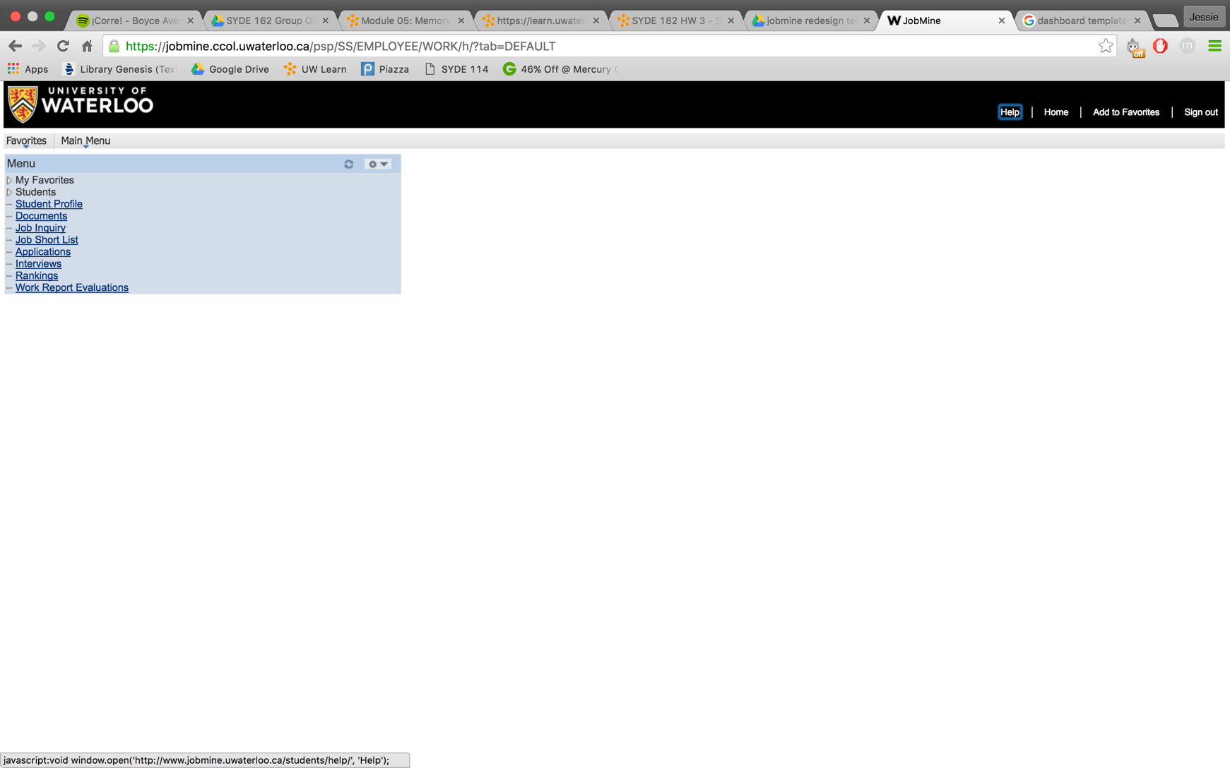

* Does not take up entire page (D1)
* Very small, hard to read (D1)
* Not in any logical order
* Lots of jargon/unclear words (ie. Job Inquiry + Documents) (D11)
* Unnecessary options (ie. Favourites) (C1)
* Not a practical home screen
* Unnecessary information (not useful for students) (D5)
* Does not take up entire page (useless space) (D1)
* Small save button (D4)

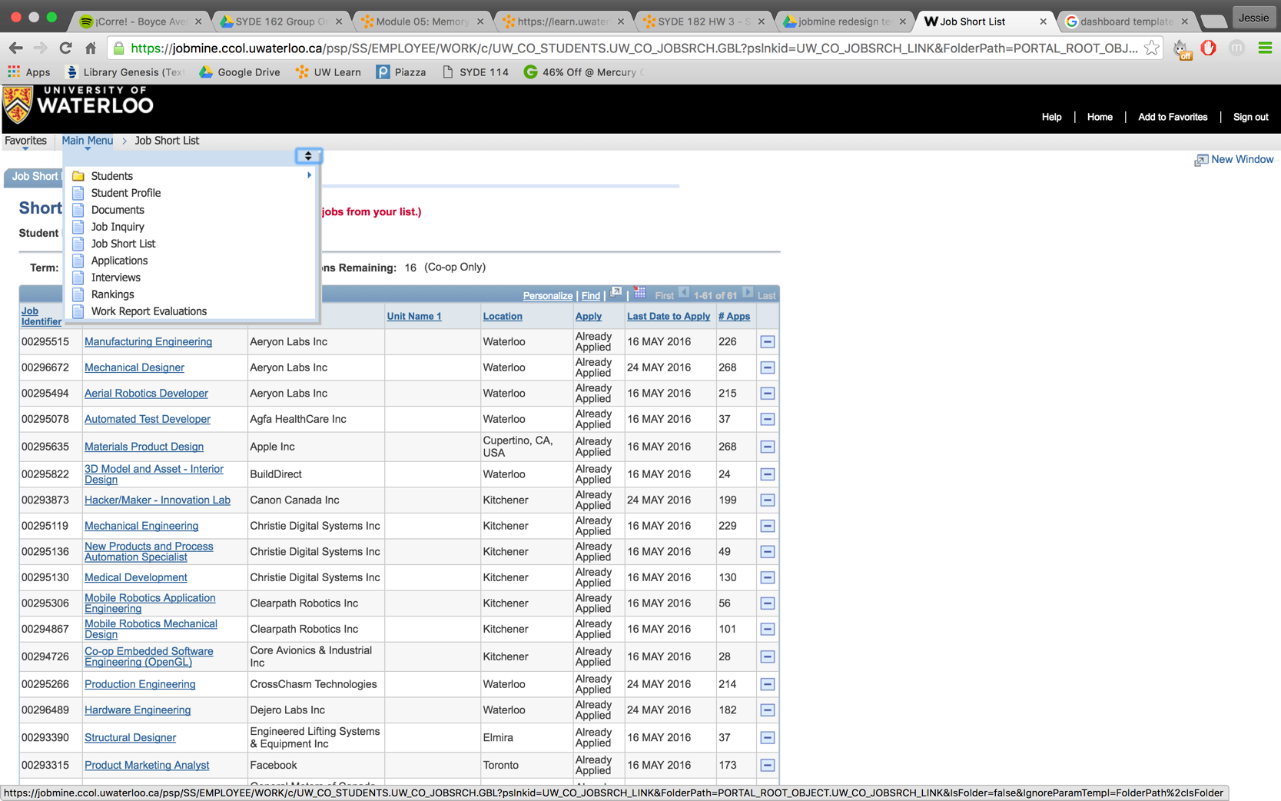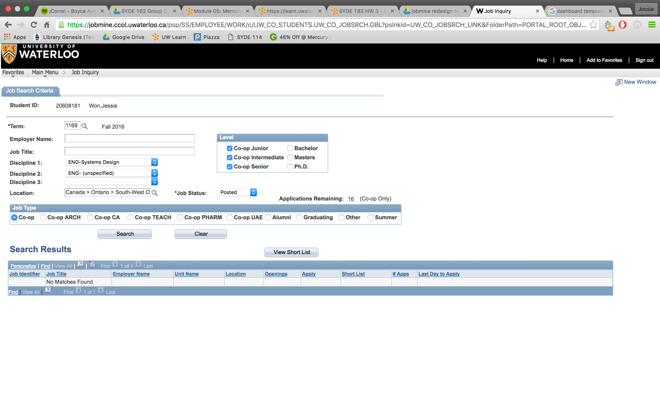

* Lots of unnecessary criteria (C1)
* Indirect information selection (ie term) (D11)
* No keyword search or real-time search (D12)
* Very small to read (very small buttons)
* Excess amount of table values (D5)
* Important information isn’t distinguishable (everything looks the same) (D3, D4, D5, D9)
* Main menu is hard to find/not accessible (D4, D8)
* No select all for job list (C1)
* Redundant save (C1)